**WORK WAVE**

**Documentation for "One-Day Job Platform"**

**Overview**

The "One-Day Job Platform" (Work Wave) is a web application that connects job providers with job seekers for short-term or one-day job opportunities. The platform consists of four main pages:

1. **Home Page (index.html)**
2. **Login & Signup Page (login7.html)**
3. **Post a Job Page (provide-job2.html)**
4. **Take a Job Page (take-job.html)**

Each page has its specific functionalities and structure, as outlined below.

**1. Home Page (index.html)**

**Purpose**

The home page serves as the entry point for users. It provides two options:

* **"Provide a Job"** - Redirects users to post a job.
* **"Take a Job"** - Redirects users to browse and accept jobs.

**Structure & Components**

* **Header**: Displays the website title, "Work Wave."
* **Main Content**:
  + Two clickable sections:
    - "Provide a Job" (Redirects to provide-job2.html)
    - "Take a Job" (Redirects to take-job.html)

**Code Summary**

* Uses styles.css for styling.
* JavaScript file script.js is included (presumably for interactive behavior).

**2. Login & Signup Page (login7.html)**

**Purpose**

Allows users to register and log in.

**Structure & Components**

* **Login Form**
  + Fields: Email, Password.
  + Social login buttons (Google, Facebook, GitHub, LinkedIn).
  + "Forgot Password" link.
  + "Sign In" button.
* **Signup Form**
  + Fields: Name, Email, Password.
  + Social login buttons (Google, Facebook, GitHub, LinkedIn).
  + "Sign Up" button.
* **Toggle Panel**
  + Allows switching between login and signup.

**Code Summary**

* Uses embedded CSS and imports Google Fonts.
* Uses JavaScript (register1.js) for form validation and interactivity.
* Implements a dynamic form-switching feature.

**3. Post a Job Page (provide-job2.html)**

**Purpose**

Allows employers to post job opportunities.

**Structure & Components**

* **Job Marquee Section**  
  Displays scrolling job categories (e.g., Event Staff, Photographer, Musician).
* **Job Posting Form**
  + Input Fields:
    - Job Title
    - Job Description
    - Price
    - Image Upload (with preview feature)
  + Submit Button to post a job.
* **Job Posting Logic**
  + JavaScript ensures that required fields are filled.
  + Displays a success message after submission.
  + Resets form fields after job submission.

**Code Summary**

* Uses styles.css for design.
* JavaScript handles form validation, success messages, and image preview.

**4. Take a Job Page (take-job.html)**

**Purpose**

Allows job seekers to view and accept available jobs.

**Structure & Components**

* **Header**: Displays "Available Jobs" with a "Home" button.
* **Main Section**:
  + Contains a list of available jobs (<ul id="jobList">).

**Code Summary**

* Uses styles.css for styling.
* script.js likely fetches and displays job listings dynamically.

**WIREFRAME**

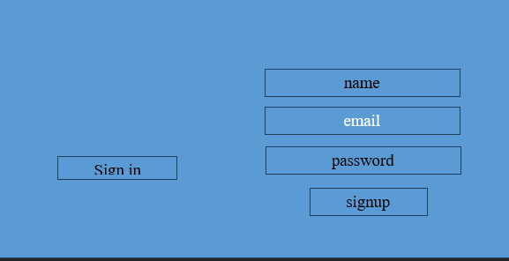

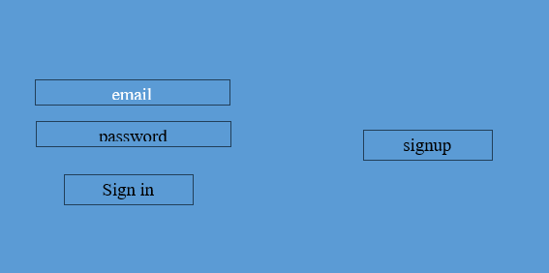



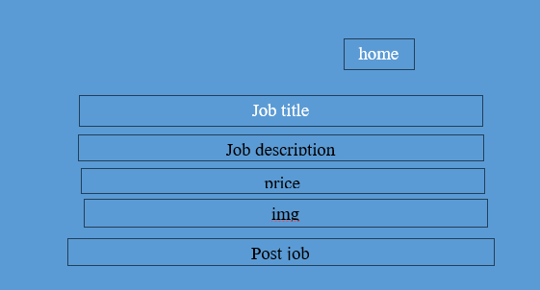

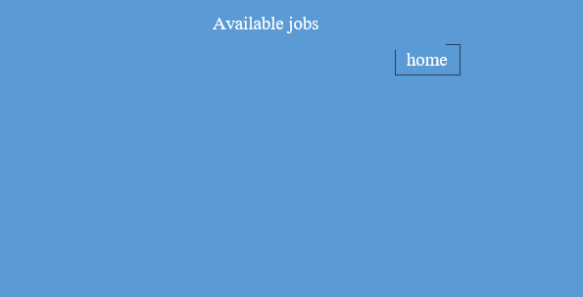

**IMAGES**

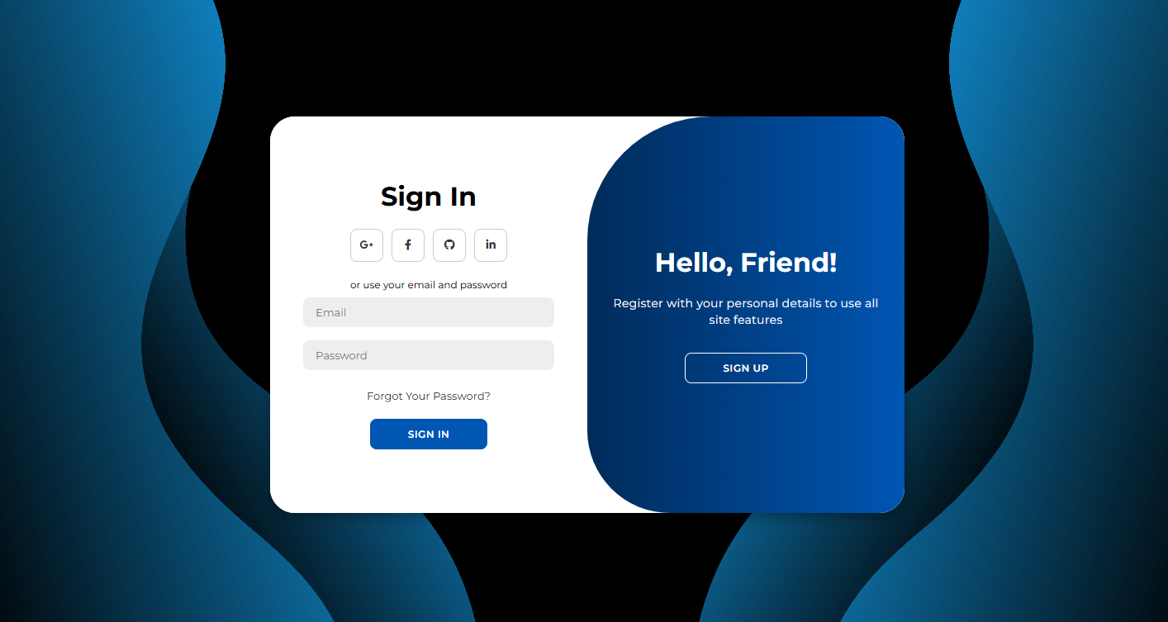

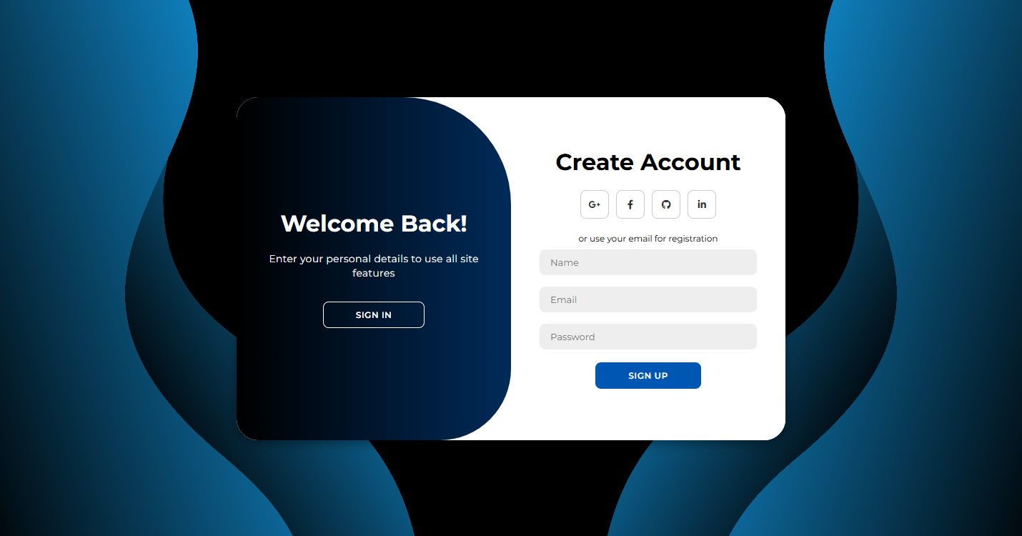

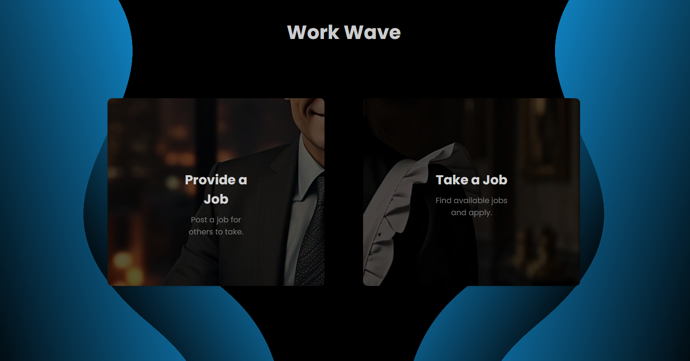

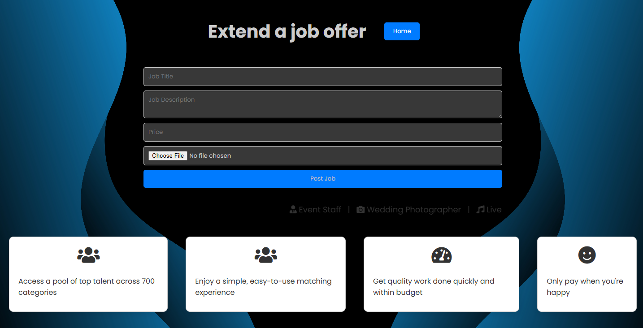



**Conclusion**

The **One-Day Job Platform** is a dynamic and user-friendly system designed to connect job providers with job seekers efficiently. This platform ensures a seamless experience with functionalities such as job posting, job application, secure authentication, and intuitive navigation.

By implementing a structured approach with firebase for backend management, along with interactive UI elements, this platform enhances accessibility and usability. The dynamic form interactions, sorting, searching, and validation mechanisms ensure a smooth and reliable experience for users.

Through this documentation, we have outlined the design, wireframes, functionalities, and implementation details of each page, ensuring a clear roadmap for further enhancements and maintenance. This project serves as a scalable solution for short-term job opportunities, fostering better connections between job providers and seekers.

Submitted to

Mr Vijay P Rao,Principal,SVMDC

Submitted by

Suhaan

Nithish

Vignesh

Dishanth